**SRS DOCUMENT**

**INTRODUCTION**

This document describes the requirements and specifications of the Digital Memo System which contains details of the process and features involved in digitizing the sequence of memorandum work.

It describes the functional feature and non-functional requirements of the program such as interface, design and other details related to the Digital Memo System.

This project is an alternative for the old manual way of sending memos with papers.

The digital memorandum is to help with easy memo record keeping for employees. The system automates your collection, validation and approval of departmental memos.

The system will be used by the stakeholders of the organization.

**USER PROBLEMS**

**PROBLEMS OF THE CURRENT SYSTEM**

1. The problem of modification. It is less flexible and cannot be changed when there is a mistake
2. Loss or damage of the documents printed.
3. Time consuming. Manually writing the memo, printing and sending to the appropriate destination requires time and also the feedback process is not instant.
4. There is no confidentiality. It does not maintain secrecy.
5. Expensive (eg. Cost of toner)

**OVERALL DESCRIPTION**

Digitizing the whole process of composing and sending memos in the organization. It is a system to replace the existing manual system of sending memos. Most of the activities or processes in the manual system will be integrated into the new digital system but in a more efficient way.

The major features of this new system are, creation of new memos, sending and receiving memos, attaching files to memos, searching of existing memos, sending notifications, and adding comments to memos.

The users for this system will be the Personal Assistants, Head of Department, etc. The personal Assistant composes a memo and sends it to his Head of Department who receives the memo to approve it and add any comments if needed and sends it to its destination.

This system will be operated in the GRA offices by GRA staff.

**SYSTEM FEATURES**

**FEATURES OF PROPOSED SYSTEM**

* **Creation of New Memos**: The system will enable users to create and save memos. The system also will enable users to digitize the already existing memos for dissemination and archiving purposes.
* **Generating Memo templates**: The system will enable users to generate the different types of memo templates.
* **Sending of Memos to Various Recipients**: The system will enable users to send memo to users managing specific offices within theorganization.
* **Searching of Old or Existing Memos**: Old memos can be easily retrieved by use of search functionality.
* **Adding of Comments to Memos**: Once the memo has been sent and received by a recipient, the system provides for comments. Hence users can add comments to the memo and be availed to all participants in the communication.
* **Attachments**: The system will provide for attaching additional or supporting documents to the memo.
* **Filing of Documents**: The system will enable users to file and categorize memo. The filing process mimics the traditional mode of file in which files are kept in filing cabinets which in turnhas drawers and folders.
* **Sending of Notifications**: Users collaborating in a chain memo are always notified of any action, for example, approving of the memo, adding of comments.

**USE CASE DIAGRAM**

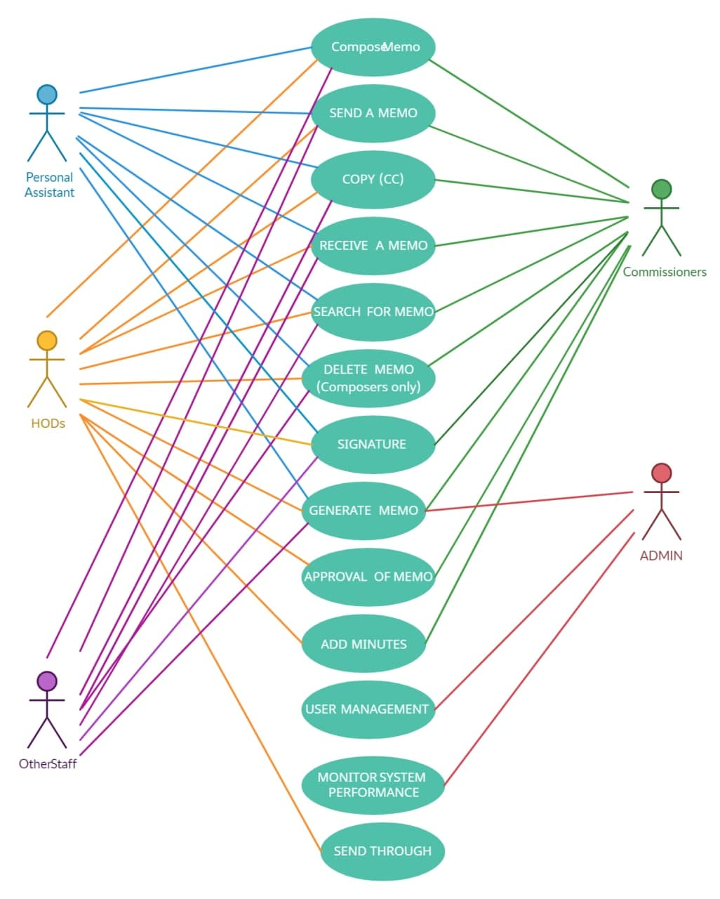

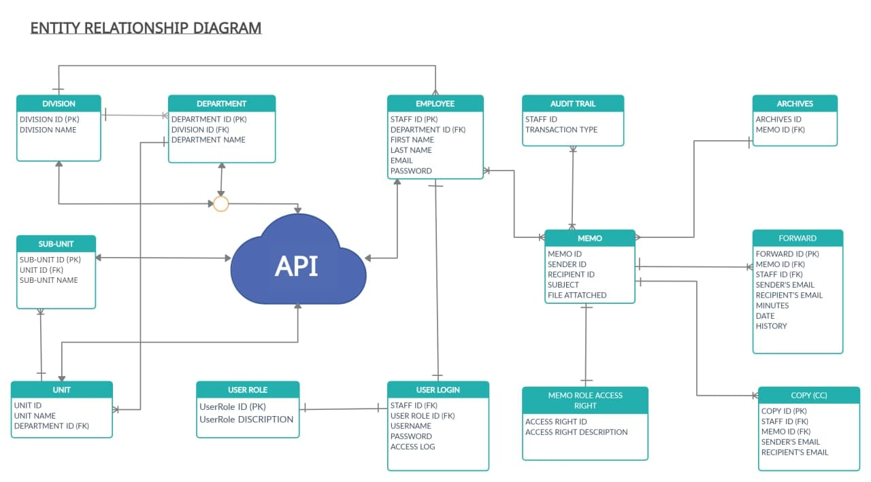

EMPLOYEE TABLE

|  |  |  |  |  |
| --- | --- | --- | --- | --- |
| Field Name | Data type | Field Length | Constraint | Description |
| STAFFID | Varchar | 10 | Primary Key | Employee’s ID |
| FIRST NAME | Varchar | 25 | Not Null | Employee’s first name |
| LAST NAME | Varchar | 25 | Not Null | Employee’s Last name |
| EMAIL | Varchar | 30 | Not Null | Employee’s email address |

DIVISION TABLE

|  |  |  |  |  |
| --- | --- | --- | --- | --- |
| Field Name | Data type | Field Length | Constraint | Description |
| DIVISION ID | Varchar | 10 | Primary Key | Division’s ID |
| STAFF ID | Varchar | 10 | Foreign Key | Employee’s ID |
| DIVISION NAME | Varchar | 30 | Not Null | Division’s Name |

DEPARTMENT TABLE

|  |  |  |  |  |
| --- | --- | --- | --- | --- |
| Field Name | Data type | Field Length | Constraint | Description |
| DEPARTMENT ID | Varchar | 10 | Primary Key | Department’s ID |
| DIVISION ID | Varchar | 10 | Foreign Key | Division’s ID |
| DEPARTMENT NAME | Varchar | 30 | Not Null | Department’s Name |

UNIT TABLE

|  |  |  |  |  |
| --- | --- | --- | --- | --- |
| Field Name | Data type | Field Length | Constraint | Description |
| UNIT ID | Varchar | 10 | Primary Key | Unit’s ID |
| UNIT NAME | Varchar | 30 | Not Null | Unit Name |
| DEPARTMENT ID | Varchar | 10 | Foreign Key | Department’s ID |

SUB-UNIT TABLE

|  |  |  |  |  |
| --- | --- | --- | --- | --- |
| Field Name | Data type | Field Length | Constraint | Description |
| SUB-UNIT ID | Varchar | 10 | Primary Key | Sub-Unit’s ID |
| SUB-UNIT NAME | Varchar | 30 | Not Null | Sub-Unit Name |
| UNIT ID | Varchar | 10 | Foreign Key | Department’s ID |

MEMO TABLE

|  |  |  |  |  |
| --- | --- | --- | --- | --- |
| Field Name | Data type | Field Length | Constraint | Description |
| MEMO ID | Varchar | 10 | Primary Key | Memo’s ID |
| SENDER ID | Varchar | 10 | Foreign Key | Sender’s ID |
| RECIPIENT ID | Varchar | 10 | Foreign Key | Recipient’s ID |
| SUBJECT | Varchar | 255 | Not Null | Memo’s subject |
| FILE ATTACHED | MEDIUMBLOB | Up to 16Mb | Unique | The file attached to the memo |

FORWARD TABLE

|  |  |  |  |  |
| --- | --- | --- | --- | --- |
| Field Name | Data type | Field Length | Constraint | Description |
| FORWARD ID | Varchar | 10 | Primary Key | Forward ID |
| MEMO ID | Varchar | 10 | Foreign Key | Memo’s ID |
| STAFF ID | Varchar | 10 | Foreign Key | Employee’s ID |
| SENDER’S EMAIL | Varchar | 30 | Not Null | Sender’s email address |
| RECIPIENT’S EMAIL | Varchar | 30 | Not Null | Recipient’s email address |
| MINUTE | Varchar | 255 | Not Null | Minutes on the memo |
| DATE | Date | 3 bytes | Not Null | Date of the memo |
| HISTORY | Varchar | 255 | Not Null | History of the memo |

COPY(CC) TABLE

|  |  |  |  |  |
| --- | --- | --- | --- | --- |
| Field Name | Data type | Field Length | Constraint | Description |
| COPY ID | Varchar | 10 | Primary Key | Copy ID |
| MEMO ID | Varchar | 10 | Foreign Key | Memo’s ID |
| STAFF ID | Varchar | 10 | Foreign Key | Employee’s ID |
| SENDER’S EMAIL | Varchar | 30 | Not Null | Sender’s email address |
| RECIPIENT’S EMAIL | Varchar | 30 | Not Null | Recipient’s email address |

USER ROLE TABLE

|  |  |  |  |  |
| --- | --- | --- | --- | --- |
| Field Name | Data type | Field Length | Constraint | Description |
| UserRole ID | Varchar | 10 | Primary Key | The ID for UserRole |
| UserRole DESCRIPTION | Varchar | 30 | Not Null | The role/rank of the user |

MEMO ROLE ACCEESS RIGHT

|  |  |  |  |  |
| --- | --- | --- | --- | --- |
| Field Name | Data type | Field Length | Constraint | Description |
| ACCESS RIGHT ID | Varchar | 10 | Primary Key | The access right ID |
| ACCESS RIGHT DESCRIPTION | Varchar | 20 | Not Null | The type of access right the user has |

USERLOGIN TABLE

|  |  |  |  |  |
| --- | --- | --- | --- | --- |
| **Field Name** | **Data Type** | **Field Length** | **Constraint** | **Description** |
| STAFFID | Char | 10 | Foreign Key | Employee’s ID |
| USERROLE ID | Varchar | 10 | Foreign Key | The ID for UserRole |
| USERNAME | Varchar | 30 | Not Null | Employee’s username |
| PASSWORD | Varchar | 20 | Not Null | Employee’s password |
| ACCESS LOG | TIMESTAMP | 19 to 32 bytes | Not Null | Employee’s access log |

AUDIT TRAIL TABLE

|  |  |  |  |  |
| --- | --- | --- | --- | --- |
| Field Name | Data Type | Field Length | Constraint | Description |
| STAFFID | Char | 10 | Foreign Key | Employee’s ID |
| TRANSACTIONTYPE | Varchar | 30 | Not Null | The transaction type |

ARCHIVES TABLE

|  |  |  |  |  |
| --- | --- | --- | --- | --- |
| **Field Name** | **Data Type** | **Field Length** | **Constraint** | **Description** |
| ARCHIVE ID | INT | 10 | Primary Key | Archive ID |
| MEMO ID | INT | 10 | Foreign Key | Memo’s ID |

**API DATABASE DIAGRAM**

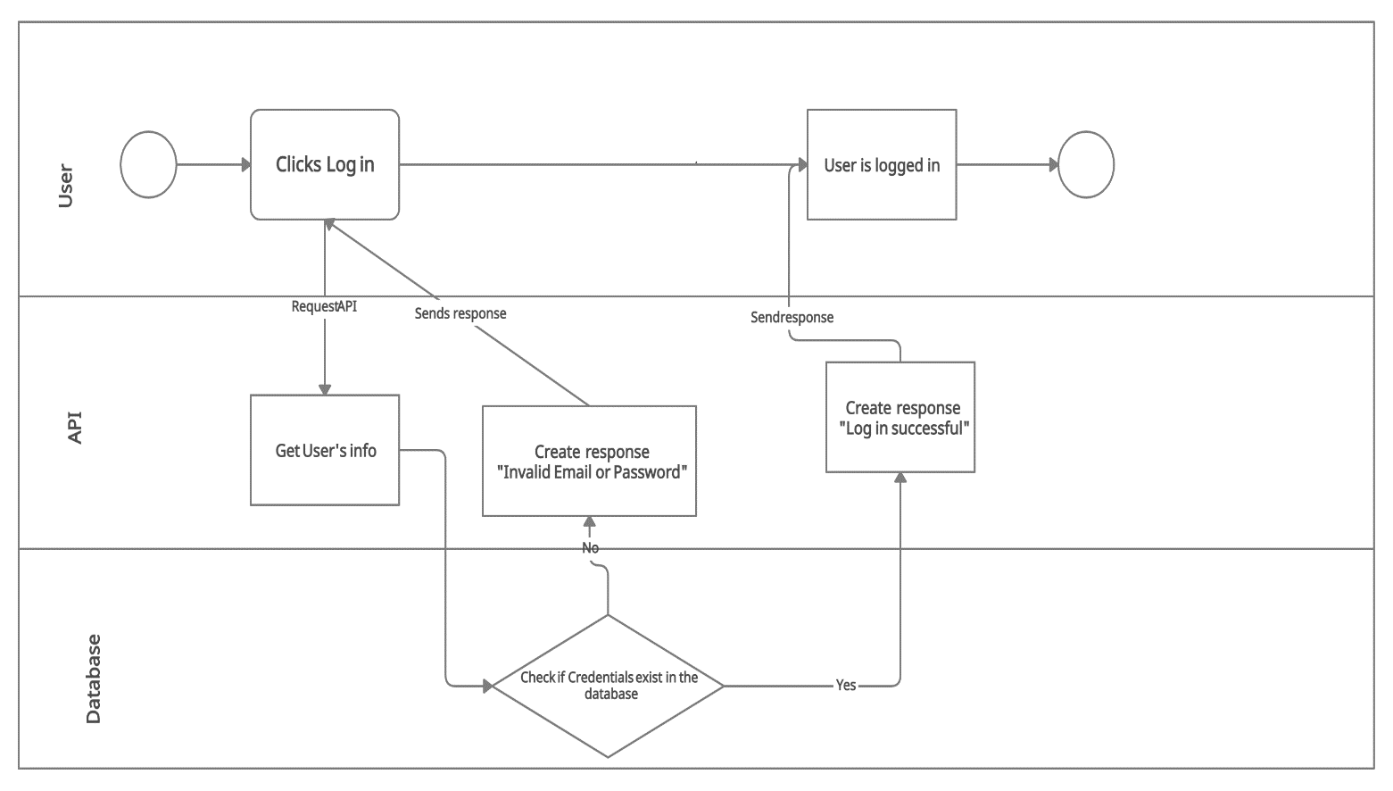

**DATA FLOW DIAGRAM**

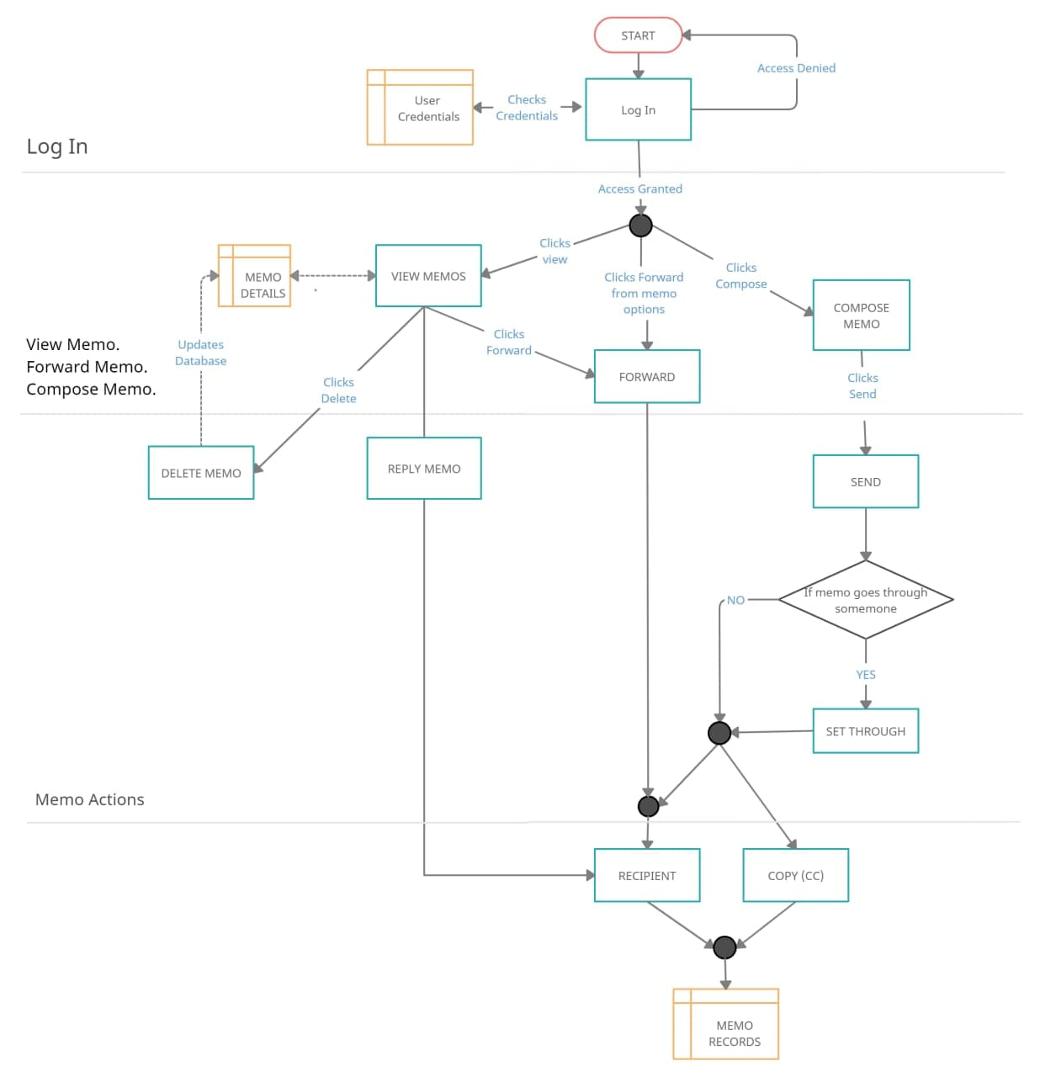

**FLOW CHART**

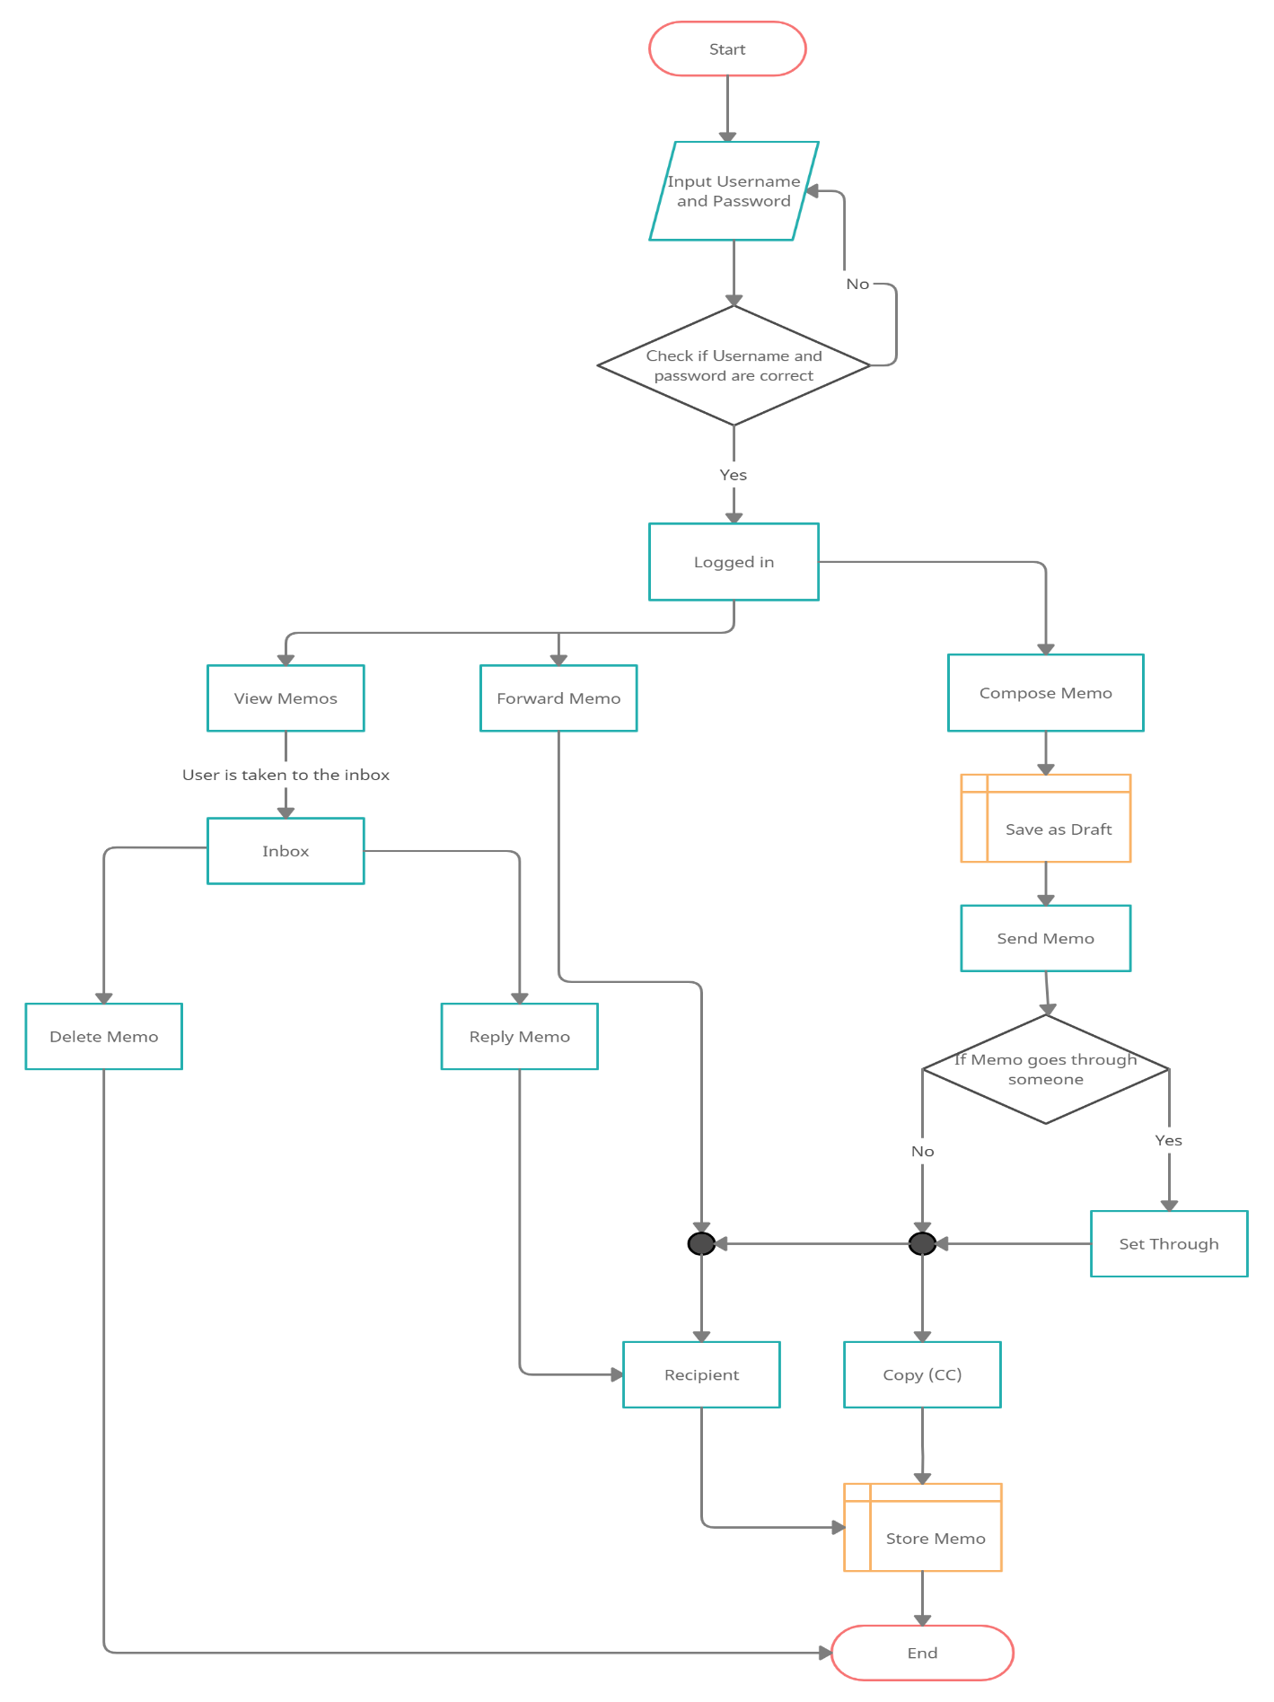

**PROTOTYPE INTERFACE**

This page comes up when the incorrect email or password is entered.

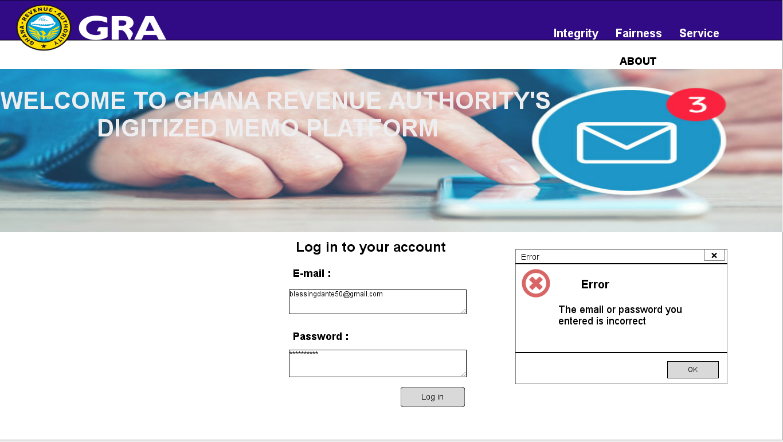

Log in with your corporate email and password.

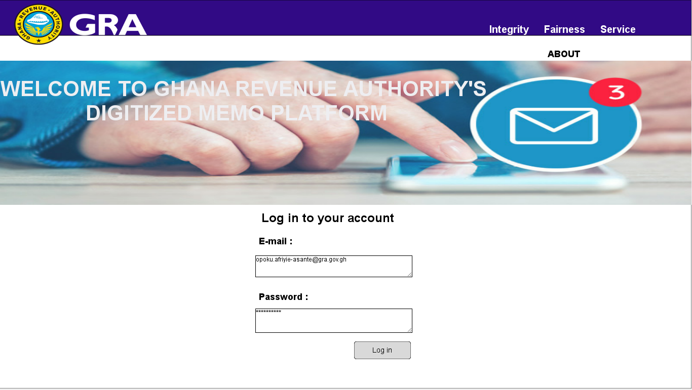

The home page appears after the user has successfully logged in.

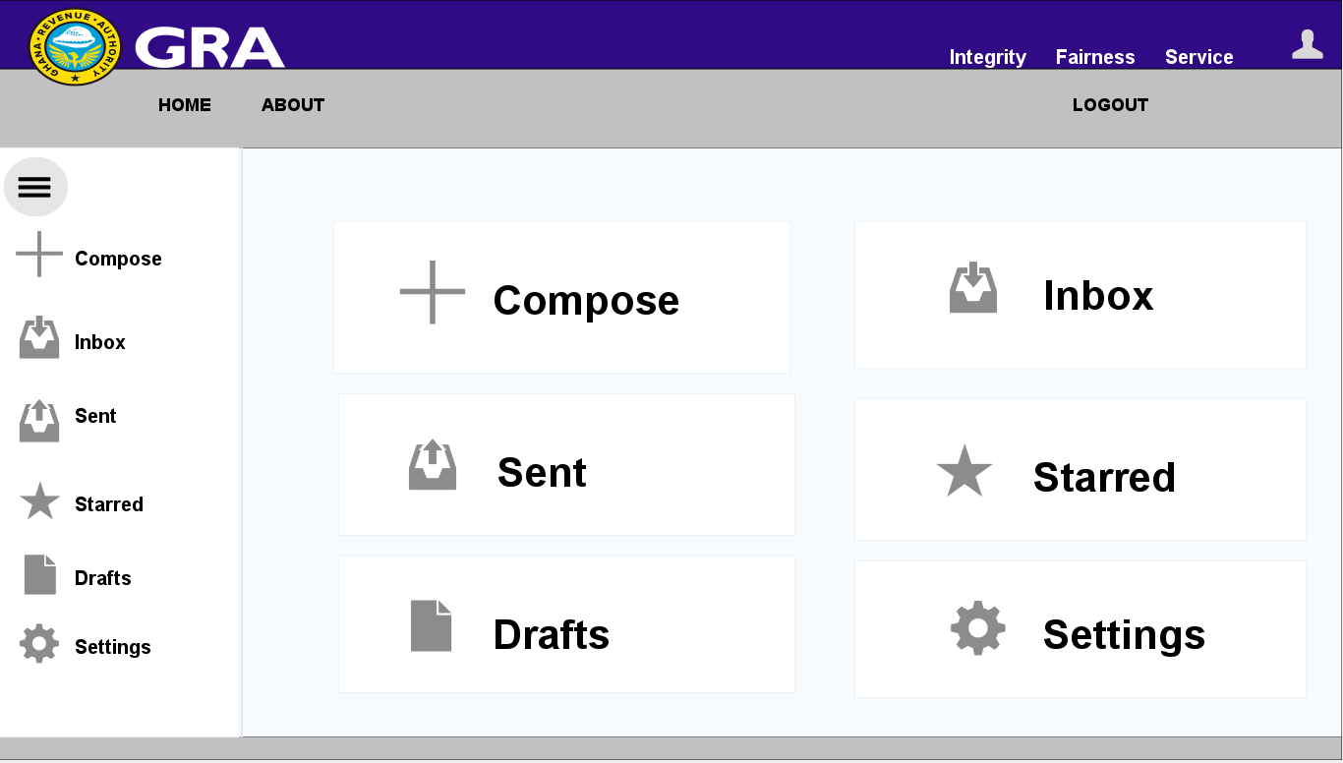

On this page, compose a memo and click on generate (From a higher rank to a lower rank).

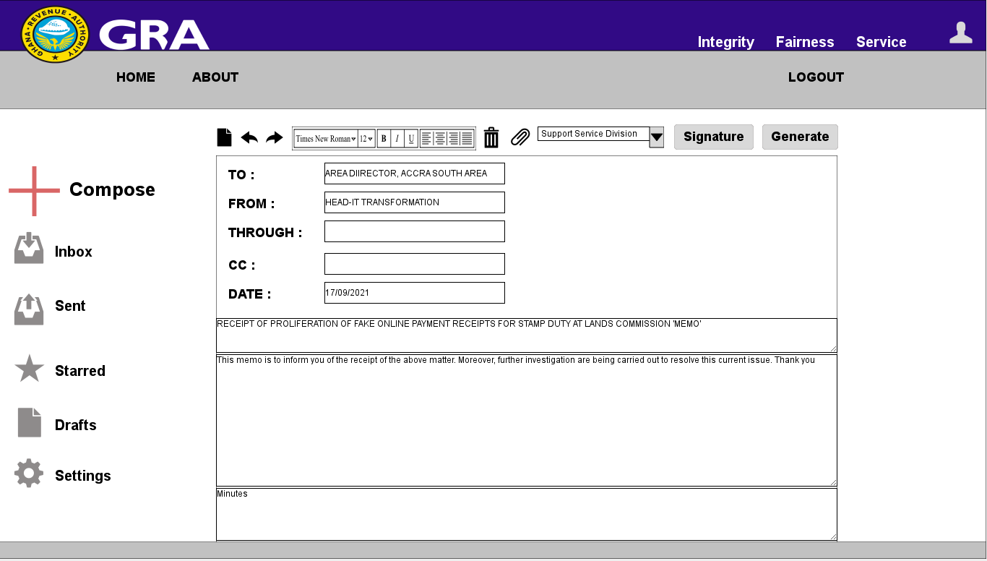

The memo is generated and can be edited, printed and sent.

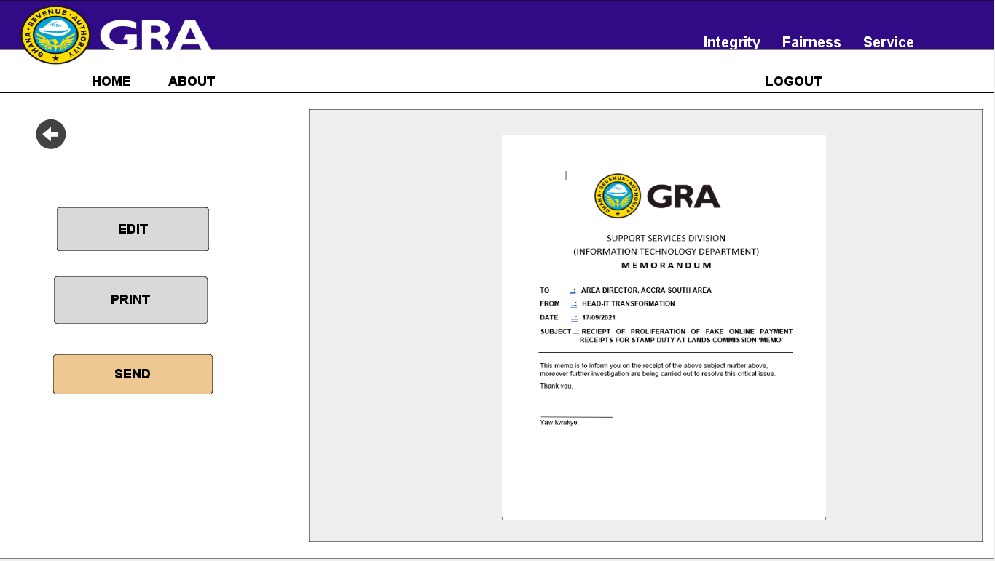

On this page, all received memos can be viewed.

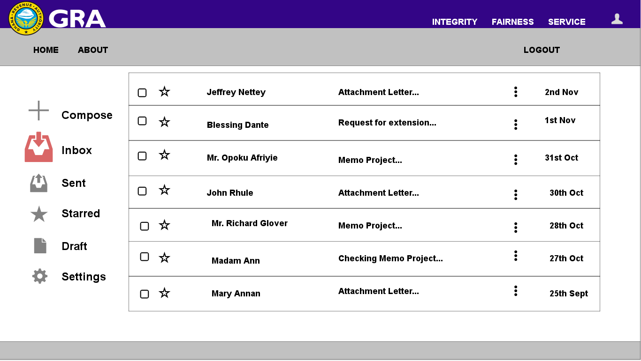

For Recipient and Set Through, you can reply, forward,delete, sign, approve and reject a received memo.

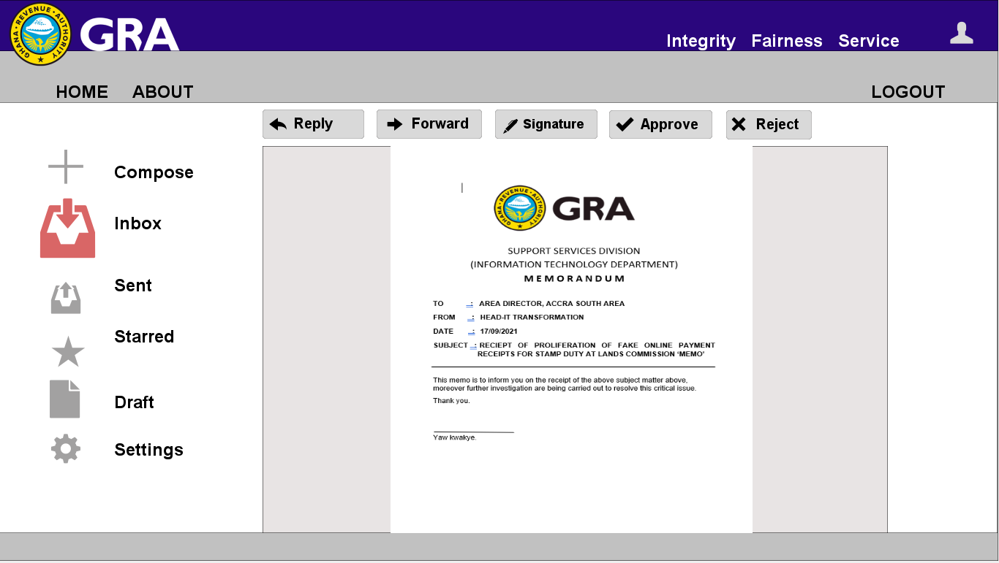

For Copy(CC), you can reply, forward and delete a received memo.

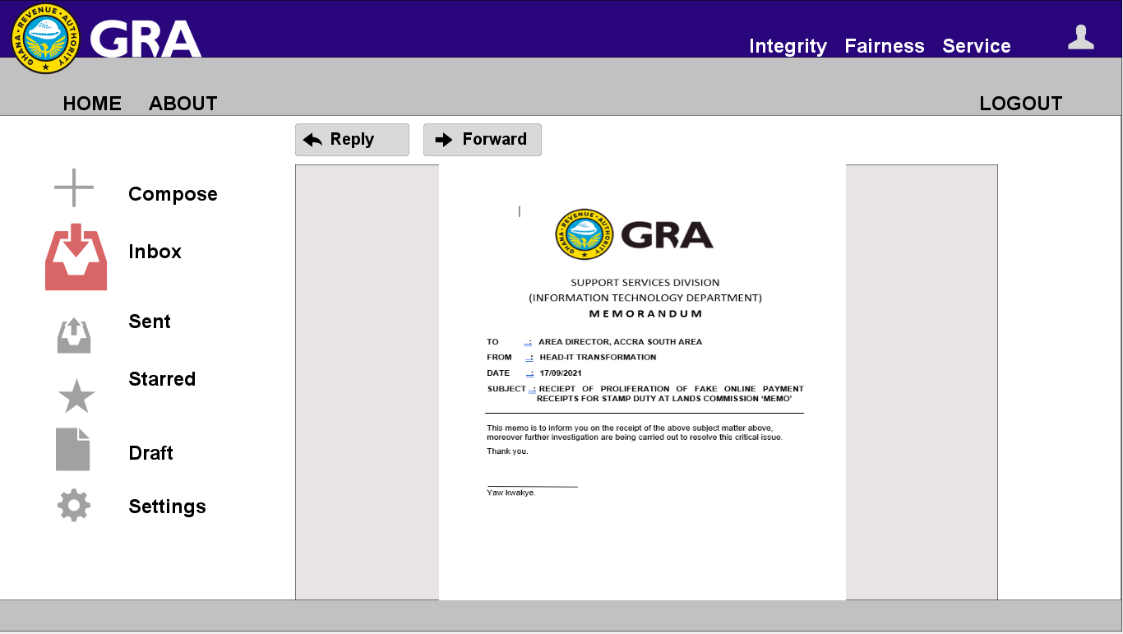

On this page, you can view all sent memos.

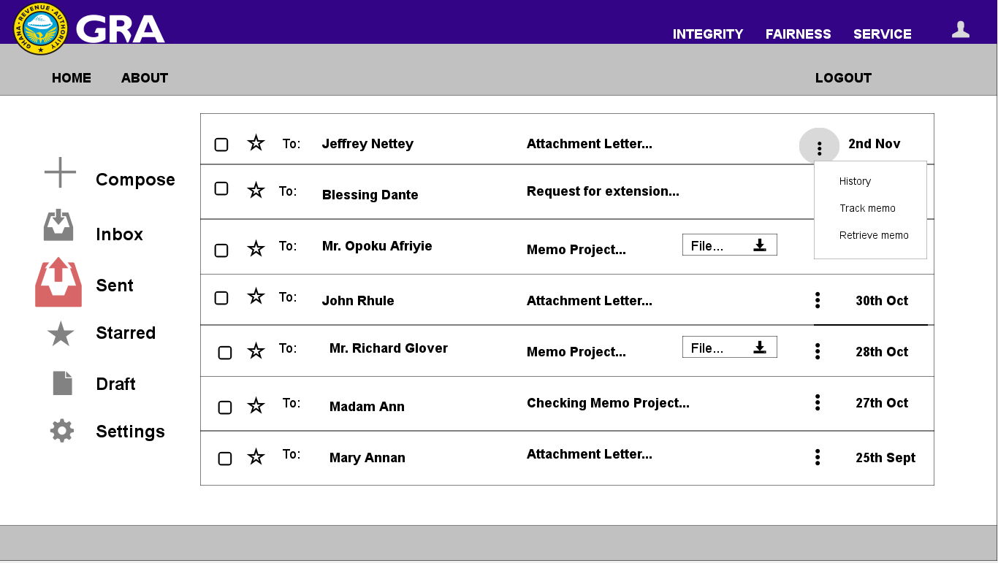

On this page, you can view all starred memos.

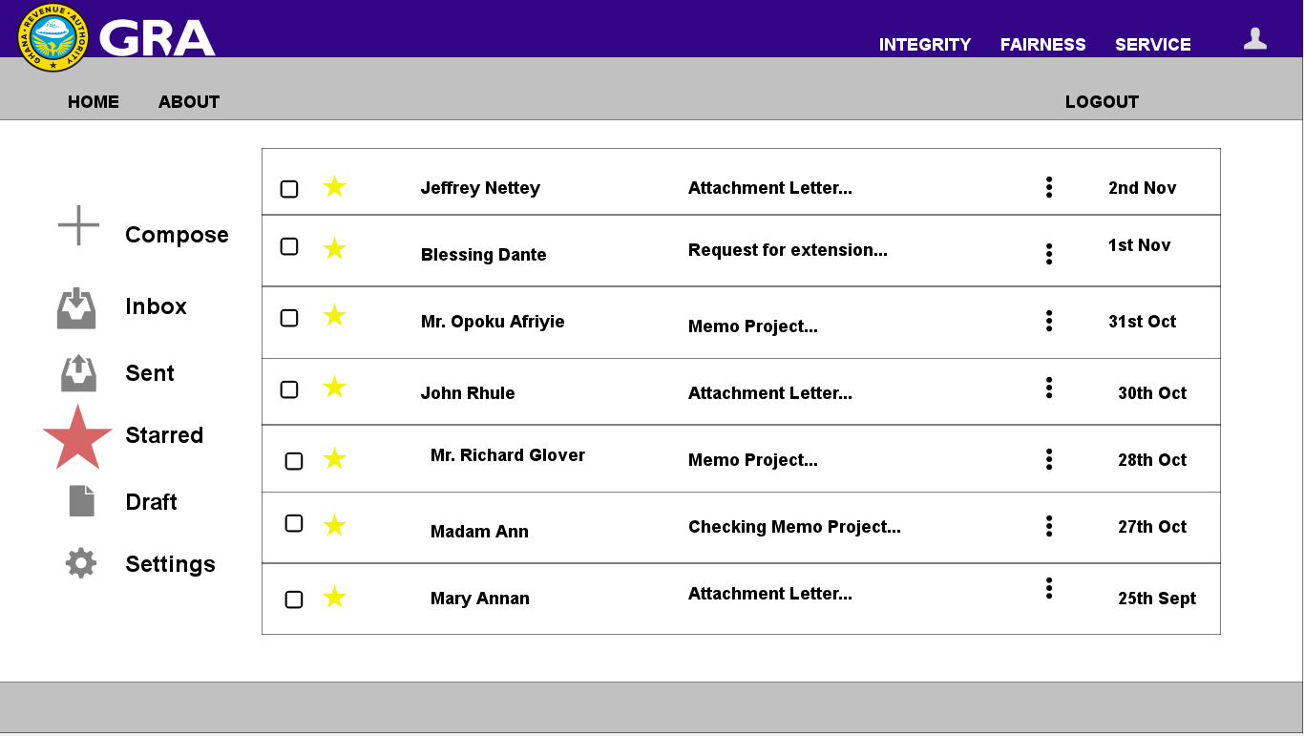

On this page, you can view all drafted memos.

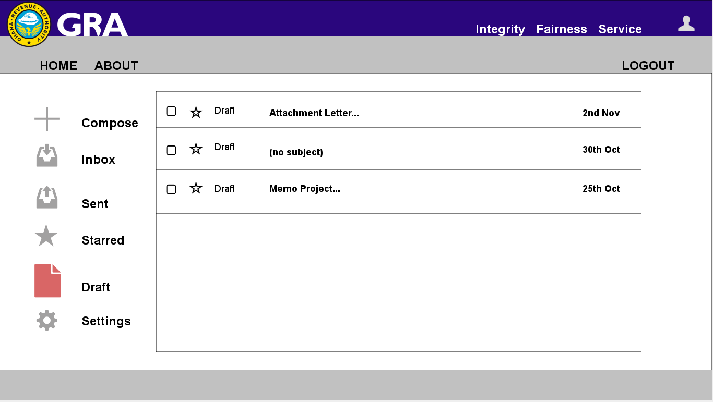

On this page you can access the settings options.

